**Experiment-5**

Kinetics Study in a Batch Reactor

*18CH10071, Anshuman Agrawal*

**Objectives**

1. To determine order of reaction between NaOH and CH3COOC2H5
2. To find the rate constant at three temperatures
3. To determine the activation energy and the frequency factor

**Theory**

Stoichiometric equation:

NaOH + CH3COOC2H5 → CH3COONa + C2H5OH

1. (B) (C) (D)

Rate equation:

$r_{A}$ = $-\frac{{dC}_{A}}{dt}$ = $k_{2}C_{2}A_{0}(1-X_{A})(M-X_{A})$ (assuming 2nd order reaction)

Where M = $\frac{C_{B_{0}}}{C_{A_{0}}}$; t = time in min; XA = conversion of A; k2 = rate constant in l gmol-1 min-1

Integrated form: $\ln{\frac{M-X_{A}}{M(1-X_{A)}}= C_{A_{0}}(M-1)k_{2}t}$, where M ≠ 1

**Apparatus**

1. Stainless steel batch reactor fitted with stirrer
2. Constant temperature bath
3. Stop Watch
4. Titration Flask

**Chemicals Used**

1. N/20 NaOH solution
2. N/50 Succinic acid solution
3. Pure ethyl acetate
4. Phenolphthalein

**Procedure**

1. 1 litre of given NaOH solution and 9 ml of ethyl acetate are added at the same time to a batch reactor and stop watch is started.
2. 5 ml solution is pipettes out of the reactor at each one-minute interval and titrated against given succinic acid solution with phenolphthalein as indicator. At least 5 samples are taken at definite time intervals.
3. Repeat the experiment for 3 temperatures: room temperature, 45 oC, and 10 oC. For low temperature, samples are taken at 2-minute intervals.
4. Titrate 5 ml of the given NaOH with succinic acid using phenolphthalein indicator to get $C_{A_{0}}^{'}$ gmol/l.
5. Find rate constant k2 from the plot of ln $\frac{M-X_{A}}{M(1-X_{A)}}$ vs t.
6. Determine at k2 at 3 different temperatures and plot ln k2 vs 1/T.

**Observations and Calculations**

CA0 = 0.048 M

CB0 = 0.091 M

Volume of sample = 5 ml

M = $\frac{C_{B_{0}}}{C_{A_{0}}}$ = 1.89583333

XA =

|  |  |  |  |  |  |  |
| --- | --- | --- | --- | --- | --- | --- |
| **Temp.(K)** | **Time (min)** | **Volume of succinic acid** | **Conc. (CA)** | **Conversion (XA)** | **ln ((M-XA)/(M(1-XA)))** | **Rate Constant (k2)** |
| 303.15 | 3 | 2 | 0.008 | 0.83333333 | 1.212725595 | 1.34186047 |
| 6 | 1.8 | 0.0072 | 0.85 | 1.302275505 |
| 9 | 1.5 | 0.006 | 0.875 | 1.460402333 |
| 12 | 1.1 | 0.0044 | 0.90833333 | 1.737359192 |
| 285.15 | 3 | 5.2 | 0.0208 | 0.56666667 | 0.481141708 | 0.98837209 |
| 6 | 4.4 | 0.0176 | 0.63333333 | 0.596737495 |
| 9 | 3.6 | 0.0144 | 0.7 | 0.743157601 |
| 12 | 3.1 | 0.0124 | 0.74166667 | 0.857224626 |
| 313.15 | 3 | 1.3 | 0.0052 | 0.89166667 | 1.5870419 | 1.91627907 |
| 6 | 1 | 0.004 | 0.91666667 | 1.824194745 |
| 9 | 0.7 | 0.0028 | 0.94166667 | 2.155006178 |
| 12 | 0.6 | 0.0024 | 0.95 | 2.300384872 |

|  |  |  |  |
| --- | --- | --- | --- |
| **Temp. T (K)** | **1/T (K-1)** | **Rate Constant (k2)** | **ln (k2)** |
| 303.15 | 0.0032987 | 1.34186 | 0.29405706 |
|  |
|  |
|  |
| 285.15 | 0.0035069 | 0.988372 | -0.01169604 |  |
|  |
|  |
|  |
| 313.15 | 0.0031934 | 1.916279 | 0.65038532 |  |
|  |
|  |
|  |

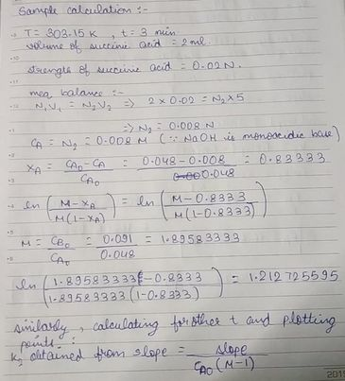

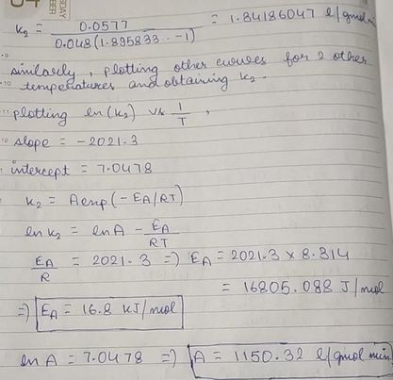

**Plots**

**Results**

|  |  |  |  |
| --- | --- | --- | --- |
| **Temp. T (K)** | **Rate Constant k2 (l gmol-1 min-1)** | **Activation Energy (kJ/ mol)** | **Frequency Factor (l gmol-1 min-1)** |
| 303.15 | 1.34186 | 16.8 | 1150.32 |
| 285.15 | 0.988372 |
| 313.15 | 1.916279 |

**Discussion**

1. On comparing the values of rate constant obtained with that of plug flow reactor and continuously stirred tank reactor, it is to be noted that the plug flow reactor gave more accurate results when compared with the value given in literature.
2. Care needs to be taken that phenolphthalein is not to be added in excess to the solution being titrated.
3. The titration should be performed carefully so as to obtain the titre value with the last drop, otherwise significant error can be observed in the calculations.
4. The lower meniscus of succinic acid in burette is to be noted correctly to avoid parallax error.
5. The rate constant at lower temperature rightly decreased as compared to other temperatures and it is evident from the Arrhenius equation.
6. Some error can also come up while handling the stopwatch, because it’s not necessary that it can be stopped at the right instant to take samples in equal intervals.
7. It’s justified to take samples at larger intervals for cold temperature because the activity is reduced and thus, a noticeable change in concentration might not be visible.